Closed Loop Control of Separately Excited DC Motor

“Closed Loop Control of Separately Excited DC Motor”

Malhar S Kulkarni
Electrical and Electronics, KLE Technological University, Hubballi, India

Problem: Simulate a closed loop control of buck converter fed separately excited dc motor drive using MATLAB/Simulink as shown below. Motor parameters are given below and you free to make suitable assumptions required for the simulation.

Keywords: Closed loop control, separately excited DC motor and DC motor.

Closed Loop Control of Separately Excited DC Motor

INTRODUCTION:

- The variable speed, reliability and high performance are three main characteristics of an electric drive system due to which it can be easily controlled. The field of motor is connected directly to the power supply for the speed control. At the same time, it is necessary for torque and speed control.

- For low horsepower dc drives are low cost. In addition to this for overhauling loads dc regenerative drives are used.

- By field control method and armature control method wide range of speed control both above and below the rated speeds are achieved. Therefore, dc motors are used in fine speed applications such as in paper mills and in rolling mills. In general, on the basis of dc motor excitation the dc motor is classified into two types. They are separately excited and self-excited dc motor. In this project we used separately excited dc motor. Hence its field winding and armature are excited from two different sources. The fundamental of electric drives, power electronic circuits, devices and application are explained in detail.

CONSTRUCTION AND WORKING PRINCIPLE OF DC MOTOR

Figure {1} DC motor

Closed Loop Control of Separately Excited DC Motor

- In the figure {1} with separate supply the separately excited dc motor has field and armature winding. To excite the field, flux the field winding of the dc motor is used. For mechanical work current in armature circuit is supplied to the rotor through brush and commutator. The field flux and armature current interaction produces rotor torque. characteristics of controlled separately excited dc motor and stability analysis of separately excited dc motor respectively [4-5]. The working principle of separately excited dc motor is listed in points below.

- Point 1: The field current {if} excites the separately excited dc motor.
- Point 2: In the circuit armature current {ia} flows.
- Point 3: To balance load torque at particular speed. The motor develops a back emf and torque.
- Point 4: Any change in armature current has no effect on the field current {if independent of ia}.
- Point 5: The field current {if} is much less than the armature current.

MATHEMATICAL EQUATIONS OF SEPERATELY EXCITED DC MOTOR
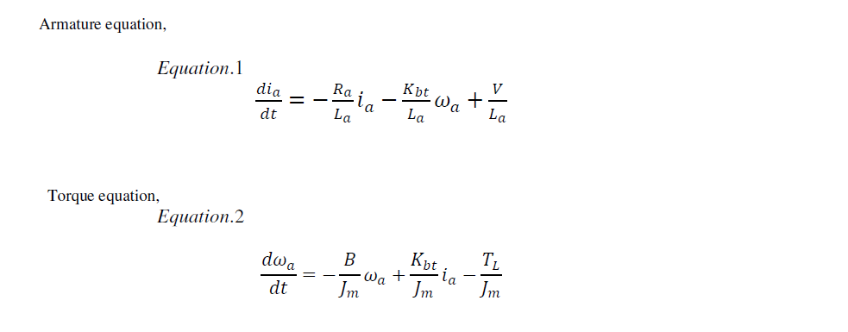
Where,
𝑉 : Voltage applied to armature in Volts.
ia : Armature current in Ampere.
𝑅𝑎 : Armature resistance in Ohm.
𝐿𝑎 : Inductance of the armature in Henry.
TL : Load torque in N-m.
𝜔𝑎 : Mechanical speed of the motor in rad/sec.
B : Damping coefficient.
Jm : Moment of inertia of the motor.
Kbt : Machine coefficient.

Closed Loop Control of Separately Excited DC Motor

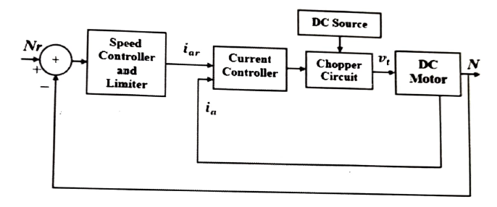

Parameter (Unit) Value

Rated power (hp) 5
Armature resistance, R (Ω) 2.581
Armature inductance, L, (H) 0.0281
Armature voltage, V,(V) 240
Field resistance. Rr (S2) 281.3
Field inductance. Lr (H) 156
Field voltage, V, (V) 300
Mechanical inertia, Jm (kg.m²) 0.0221
Friction coefficient, B (N.m.s) 0.002953
Back emf constant, K, (V/rad/sec) 1.25
Motor torque constant, K, (N.m/A) 0.516
Rated speed, Ѡ_{r}, (rpm) 1750

Closed Loop Control of Separately Excited DC Motor

SIMULATION MODEL OF DC MOTOR:

- Armature resistance {Ra} =1.8 ohms
- Armature inductance {La} =0.0281H
- Moment of inertia { Jm } =0.0221 kg/m2
- Machine coefficient { Kbt } =1.25 v/rad
- Rated terminal voltage {Va} =240 volt
- Damping coefficient {Bm} = 0.002953 nm/rad/s
- Rated armature current {Ia} = 13.63 Amps
- Load torque {TL} =19.07 N-m
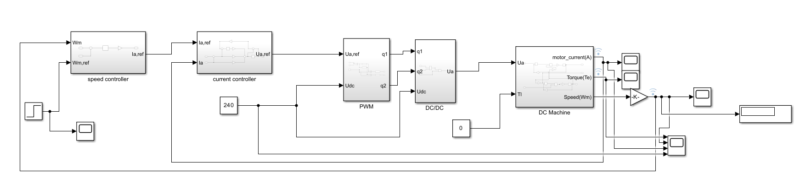

Figure {2} Simulation model of closed loop separately excited dc motor

The output speed of the separately excited DC motor is compared with given reference speed. From the comparison, the speed error and change in speed error are calculated and given as input to the controllers.
Output of the controller is given to the current controller as reference current. The current controller performs the comparison between reference current and actual armature current of DC motor. Based on the comparison, it generates the gate signal for chopper drive which is turn controls the input voltage given to the motor.

Closed Loop Control of Separately Excited DC Motor
Figure {3} speed controller subsystem

The speed controller is present in the outer loop. An increase in the reference speed ωm produce a positive error Δ ωm. Speed error is processed through the speed controller and further given to next subsystem .

Figure {4} Current controller subsystem

Current controller is present in the inner loop. It is provided to limit the converter and motor torque below a safe limit.

Closed Loop Control of Separately Excited DC Motor
Figure {5} PWM subsystem

The PWM sub system is present to give the PWM pulses to the DC-DC converter. The converter requires the pulses for switching of the devices present in it.

Figure {6} DC/DC subsystem

This figure represents the operation of the DC-DC converter that converts DC voltage from one level to another level. It receives the pulses required for the conversion through the PWM subsystem.

Closed Loop Control of Separately Excited DC Motor
Simulation results:
Case 1: Step disturbance in reference speed from 50% rated speed to rated speed (Performing this at no load condition and at rated voltage.)

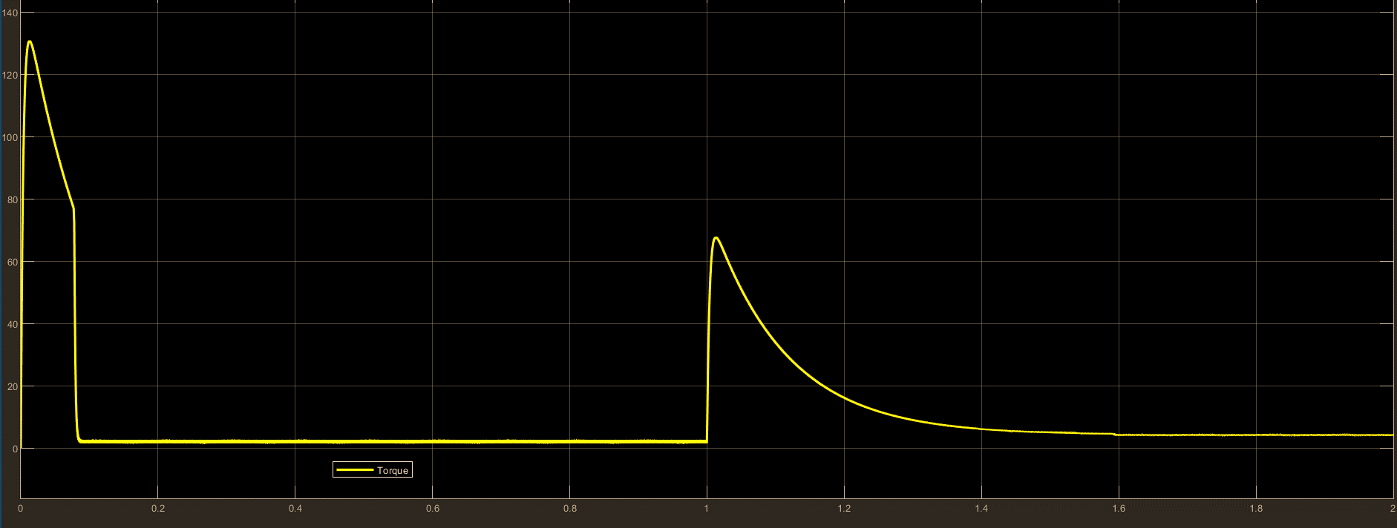

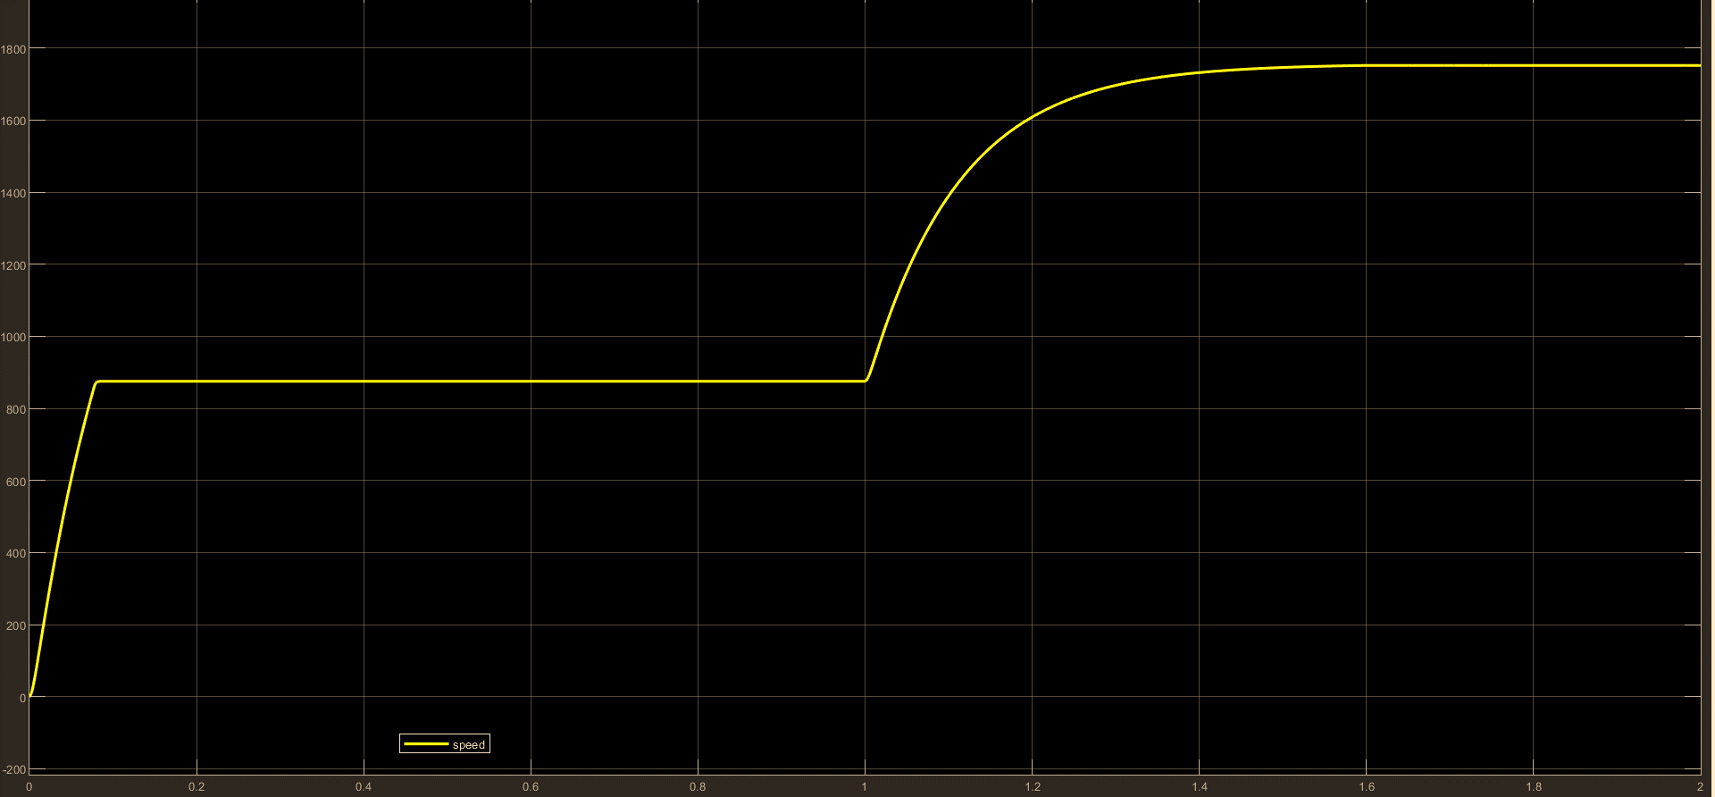

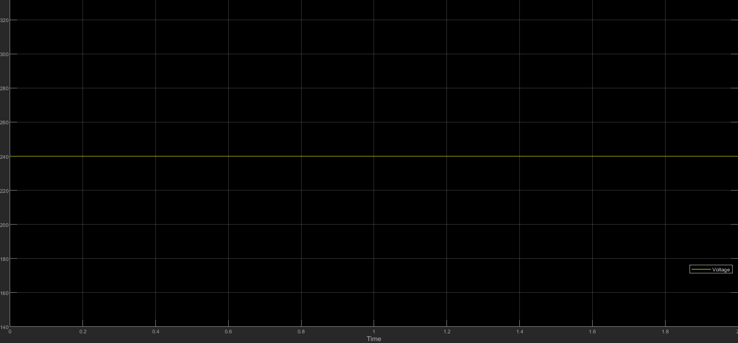

Figure {7} graphical representation of the response given by the Separately Excited DC Motor at Step disturbance in reference speed from 50% rated speed to rated speed
Closed Loop Control of Separately Excited DC Motor

The figure shows the graphical representation of the response given by the Separately Excited DC Motor at Step disturbance in reference speed from 50% rated speed to rated speed at no load condition and at rated voltage. The first curve in the red represent the variation of the load torque, the second curve in the black represents the variation of the speed, the third curve in the blue represents the variation of the voltage.

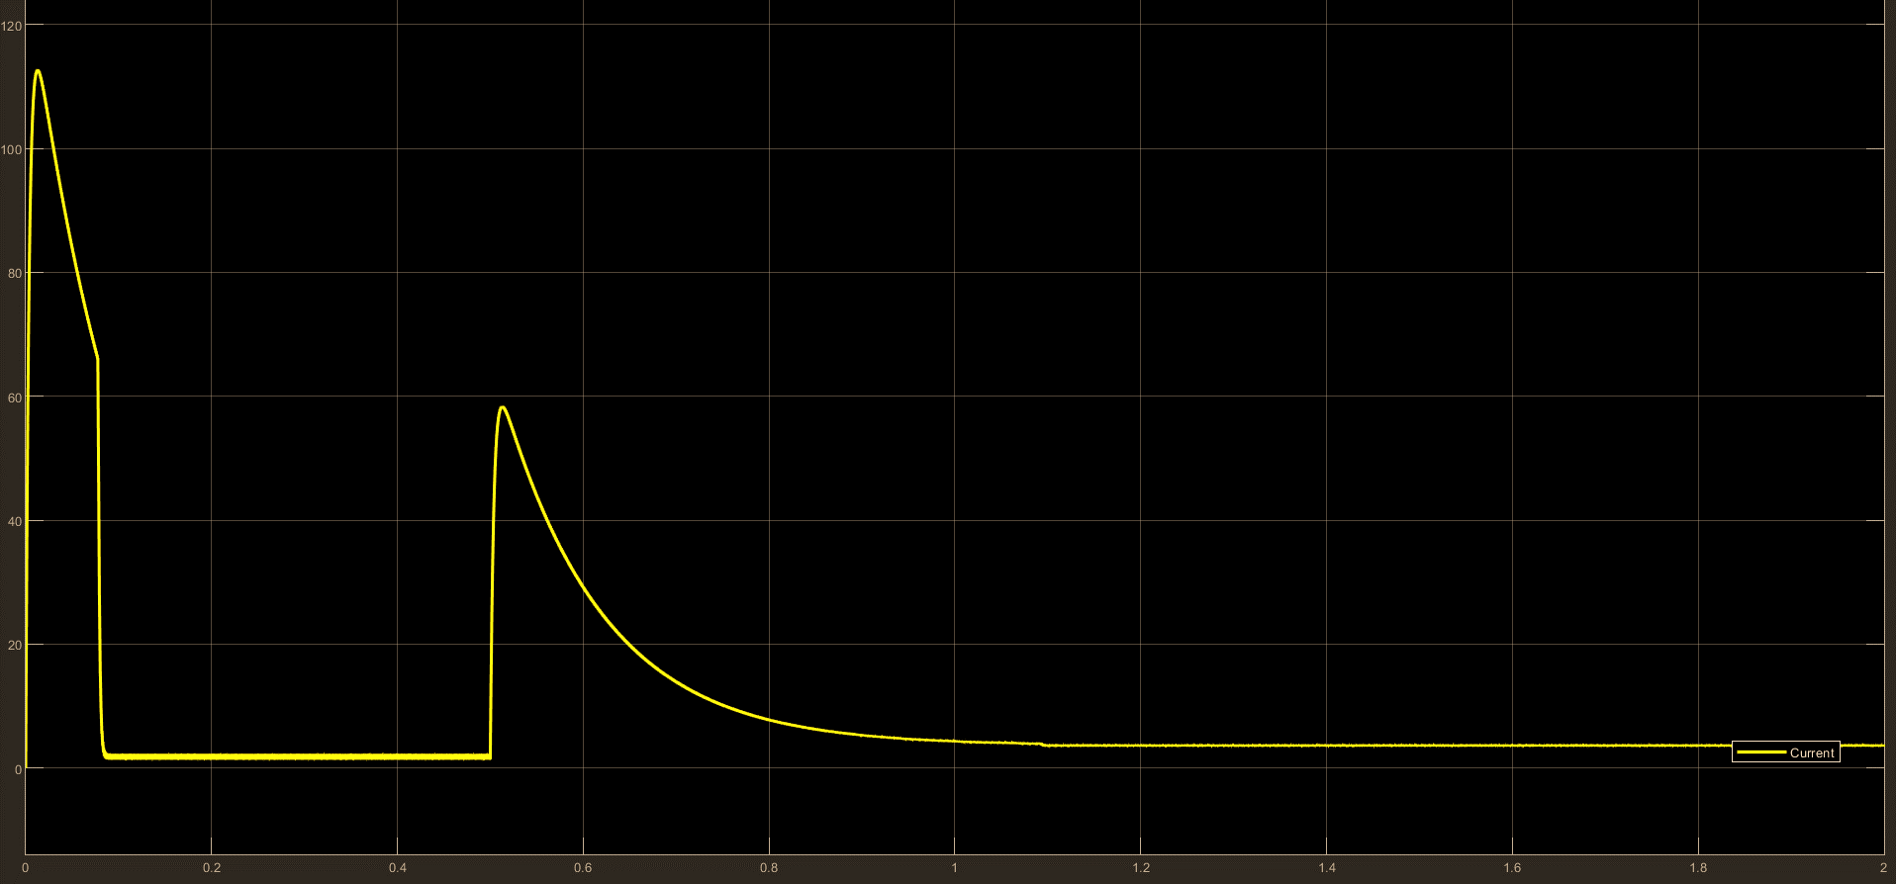
Figure {8} graphical representation of the response given by the Separately Excited DC Motors current at Step disturbance in reference speed from 50% rated speed to rated speed

The curve in the figure above represents the variation in the current when there is Step
disturbance in reference speed from 50% rated speed to rated speed.

CONCLUSION:
The closed control loop for speed regulation of separately excited DC motor for the disturbances mentioned in the problem has been done successfully.
The nature of the torque, current, voltage and speed for the given disturbance is obtained

